Project Report Automatization
  - Transforming Unstructured Reports into Actionable Insights
Business analysis

Jan Bartyzal
2. 3.2026 version:1.2
Contents
Executive Summary 3
Business Analysis 3
Assignment 3
Current State Analysis 3
Operational inefficiency 3
Data silos and fragmentation 4
High risk of error 4
Information Delay 4
Analysis summary 4
Identified GAPs 4
Data sources 4
Data normalization 4
Security and Compliance 4
Scalability 5
Data sovereignty 5
Auditability and versioning 5
Sustainability of the solution 5
Modified assignment 5
Proposed solution 5
Approach principles 6
Structured data collection principle 6
Intelligent ingestion Principle 6
Reporting lifecycle & approval workflow principle 7
Standardized report generation principle 7
Dynamic visualization & benchmarking principle 7
Benefits 7
Expectations 7
Platform Extensibility 7

Executive Summary
The project aims to transform the holding company's financial reporting from a manual, error-prone process to a fully automated data platform. By implementing technology for extracting data from unstructured files (PPTX, Excel), we eliminate 90% of manual work, increase data accuracy, and reduce consolidation time from days to minutes.

Business Analysis

Assignment
The project assignment focused on the need to load PPTX files, analyze data in tables and pseudo-tables, and save the obtained data and enable its insertion into a summary Excel. The benefit is to facilitate the work of compiling data from individual companies and speed up the preparation of a summary report.

Current State Analysis
The existing OPEX reporting process relies entirely on manual effort and file-based communication between subsidiary units and headquarters. Each subsidiary independently prepares its data in Excel, then manually builds a PowerPoint presentation following a corporate template. In addition, a separate Excel file containing raw numerical data is created alongside the presentation, as the PowerPoint format alone does not allow for efficient downstream data processing.
Once both files are ready, the subsidiary sends them to headquarters — typically via email or a shared drive. At headquarters, an analyst must open each file individually, manually re-type or copy-paste the data into a consolidation spreadsheet, reconcile inconsistencies across units (naming conventions, structural differences, missing fields), and ultimately build a summary presentation by hand. This process is repeated for every reporting period and every subsidiary, creating significant overhead. The key pain points include: high risk of human error during manual data re-entry, lack of data versioning or audit trail, no standardized validation at the point of entry, and substantial time spent on consolidation rather than analysis.
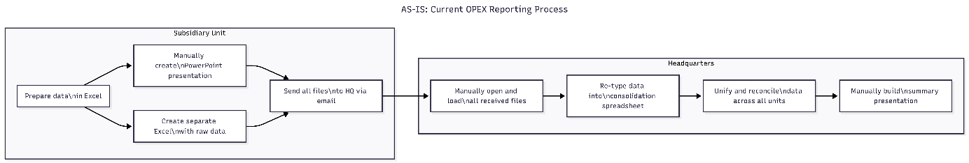

The problem can be divided into four key areas.

Operational inefficiency
Highly qualified financial controllers spend 3-5 days a month manually rewriting numbers from PowerPoints and Excels. An estimated 15-20 MD per month is lost on mechanical consolidation across the holding.

Data silos and fragmentation
Critical financial data is locked in static files on SharePoint, local drives or in email attachments. Historical data is practically inaccessible and therefore there is no "Single Source of Truth".

High risk of error
Human errors occur when manually rewriting thousands of cells (typos, shifted decimal points, bad row mapping). Errors in lead to the need for retroactive corrections and reduce confidence in the final reports.

Information Delay
It takes days to weeks to get a consolidated view after the review is delivered.

Analysis summary
The intended solution was to use Python to decompose the PPTX file into individual parts, load tables and identify pseudo-tables using OCR or AI OCR. The data obtained in this way was to be stored in a SQL database and exported to Excel. The workflow and orchestration of such a solution was intended to use the N8N tool (orchestrator), Python FastPAI for the implementation of file loading and ReactJS for the user interface. From the analysis of the solution, additional needs and requirements of users and with regard to the scope of tools that are suitable for use within the recommended ecosystem, the proposed solution was significantly expanded, which in many areas exceeded the original specifications.

Identified GAPs
During a detailed analysis of user requirements and the technical environment, 7 critical gaps were identified between the original specification and the actual business need.

Data sources
The analysis identified the need for users to upload and process several different input files, not only in relation to the OPEX report. It is appropriate to expand the input files with Excel inputs not only for OPEX reports.

Data normalization
The original specification assumed immutability or only a gradual shift in the data structure of the presentations. After expanding with various Excel files, it is necessary to build a workflow for normalizing column names in uploaded Excels for the needs of unification into the output format

Security and Compliance
OPEX data is classified as internal financial information. Uploading files without an antivirus scan, without an audit trail and without authentication would be in direct conflict with the holding's security policy.

Scalability
The original intention of the project was to build a unit that would only facilitate the processing of finished data. The analyses showed that such a tool is suitable to build and deploy across all companies that send reports. This procedure will further speed up and simplify reporting. Based on this assumption, it is necessary to change the original architecture and process the tool differently than only in Python.

Data sovereignty
The analyses revealed the need for a tool as a central one for all subsidiaries. For this reason, it is necessary to expand the scope by building authentication and security mechanisms into the project in the form of Row-Level Security, which will natively ensure the separation of company data. From the organizational perspective, the project will be expanded by a hierarchy of users and setting data access permissions, grouped into organizational units.

Auditability and versioning
Every change to input data must be versioned and a log of which user made the change must be provided. This measure will ensure that the resulting report will be trustworthy.

Sustainability of the solution
Python is an excellent tool for solving the original task. When expanding the scope, it is necessary to use other principles and architectural patterns. For this reason, the design is conceived as a division into microservices that primarily use the Java programming language and Python remains for data analysis.

Modified assignment
The new project will cover the entire OPEX reporting life cycle from its creation at the level of individual users of subsidiaries to centralized reporting. It will allow users to upload reports through the platform and confirm their status for acceptance into central reporting. The platform will allow users to upload Excel (data) files that will serve as a sub-database for generating reports in PPTX format according to a unified template. At the same time, this data will serve as source data for centralized reporting without the need to mass import PPTX files and combine the data contained in them. The platform will allow uploading of sub-database data or issuing a form for entering data for the needs of the report - the new report will not mean sending Excel files to fill out, but creating a central form and unified data collection. Delivery of the project in the form of microservices will enable the gradual fulfillment of the project goals and will allow future expansion with new modules.

Proposed solution
We propose the implementation of an Event-Driven OPEX Reporting Platform that changes the paradigm from "Document-Centric" to "Lifecycle-Centric" – covering the full reporting cycle from data creation at the subsidiary level through to consolidated holding-level reporting.
The proposed platform fundamentally restructures the reporting workflow by introducing a centralized data layer between subsidiaries and headquarters. In the new process, each subsidiary prepares its data in Excel as before — preserving familiarity and minimizing change management friction — but instead of building a presentation manually, the unit uploads the Excel file to the platform. The platform automatically generates a PowerPoint presentation from a unified template, ensuring visual and structural consistency across all units.
The subsidiary user then reviews the generated presentation, adds any non-numeric content (commentary, context, qualitative notes), and uploads the finalized version back to the platform along with the confirmed dataset. The uploaded PowerPoint serves as the subsidiary's confirmed visual deliverable; all structured data for consolidation is sourced exclusively from the validated Excel dataset, not from the presentation file. Once ready, the submission is pushed into a batch for headquarters processing. At headquarters, the platform already holds structured, validated, and versioned data from all subsidiaries. The HQ team generates its own consolidated presentation directly from the platform data — eliminating the need to open individual files, re-type figures, or reconcile formats. The entire batch, including both subsidiary and HQ presentations, is assembled as a single reporting package.

This approach eliminates redundant manual steps, enforces data consistency at the point of entry, provides full version history and audit trail, and reduces the end-to-end reporting cycle time significantly.

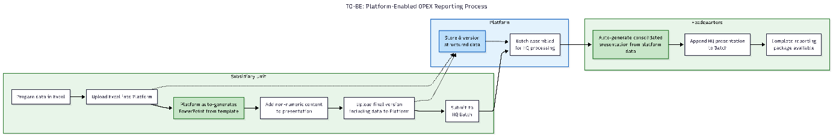

Approach principles

Structured data collection principle
Instead of sending Excel templates by email and waiting for filled files to come back, the platform provides a centrally defined form for each reporting period. Subsidiaries fill in data directly in the platform – or export the form as an Excel template, fill it offline, and import it back. Either way, data lands structured and validated from the first moment, with no manual consolidation needed.

Intelligent ingestion Principle
For cases where source data originates in external systems, users can upload files in their native format (XLSX, PPTX, PDF). The system creates a structured representation of the document in the background. Technology: OCR and advanced parsers (Atomizers) identify structure (tables, headings, values) without requiring changes to existing report templates. A Schema Mapping Registry normalizes column naming differences across subsidiaries automatically.

Reporting lifecycle & approval workflow principle
Every report follows a transparent state lifecycle – Draft → Submitted → Under Review → Approved. Each transition is logged with a full audit trail. Holding administrators have a real-time matrix view of which subsidiaries have delivered, which are pending, and which have been rejected with a reason. Automation: Deadline management triggers automatic reminders as deadlines approach, closes collection forms at the configured cutoff, and escalates overdue submissions – all without manual intervention.

Standardized report generation principle
Once data is approved, the platform generates a standardized PPTX report automatically from a centrally managed template. No more manually copy-pasting numbers into slides. Value: HoldingAdmin uploads a slide template once, defines placeholder mappings, and the system produces consistent, branded reports for every subsidiary and every period – on demand or triggered automatically upon approval.

Dynamic visualization & benchmarking principle
The output is not another static report but an interactive dashboard drawing directly from the structured source data – bypassing the need to parse PPTX files altogether. Value: Users can filter data (drill-down), compare period-on-period, or benchmark across subsidiaries with a single click. Because data enters the platform structured at the point of collection, dashboards reflect approved numbers instantly, with no ETL delay.

Benefits
Area | As-IS | To-BE | ROI
Speed | ​​3-5 days for consolidation | < 1 hour (Real-time) | 95% time savings
Accuracy | Human factor (typos) | Machine reading (OCR/Parsers) | Elimination of transcription errors
Audit | Files without change history | Versioning and Audit Log | Full compliance and traceability
Insight | Static slides | Interactive Dashboards | Faster management decision-making

Expectations
- Management (Main Sponsor) expects faster reporting and a "single source of truth".
- Key users want to get rid of "Excel hell" and do analysis instead of copy-paste.
- IT Security (compliance) requires that data does not leave the tenant (RLS, VNETs) and AI does not train on corporate data.

Platform Extensibility
A critical design principle of the platform is that it is not purpose-built solely for OPEX reporting. The core architecture — consisting of a data collection engine, a central structured data store, and a template-driven report generator — is intentionally generic and modular. OPEX reporting serves as the first implementation module, but the same infrastructure can be extended to support any structured data collection and reporting use case without architectural changes.
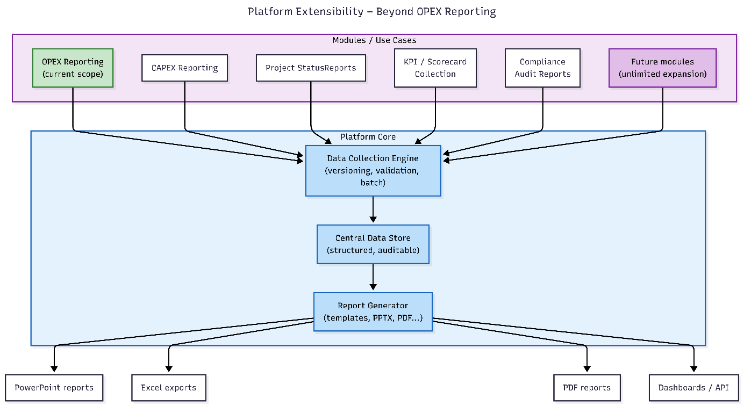

Potential future modules include CAPEX reporting, project status reporting, KPI and scorecard collection, compliance and audit reporting, or any other periodic data gathering process that currently relies on file exchange between organizational units. Each new module would define its own data schema, validation rules, and output templates, while reusing the platform's ingestion pipeline, versioning, batch workflow, and report generation capabilities. This extensibility transforms the platform from a single-purpose tool into an enterprise reporting backbone, maximizing return on the initial implementation investment.

